

FINAL PROJECT REPORT
University Clinic Management System (UniClinic)

Group Members
- Nonthando Hlongwane 22333548
- Mbali Ngwadla 22310899
- Sthembele Shamase 22359147
- Zipho Khanyile 22320153
- Bongeka Cele 22301773
- Nkosinathi Ngobese 22356737
- Olwethu Mnyayi 22328534
- Skhumbuzo Hlongwane 21404935

Contents
Introduction 2
Problem Statement 2
Aim of the Project 2
Objectives of the Project 2
Significance of the Project 3
System Review and Analysis 3
IoT Integration 4
Business Intelligence Implementation 5
System Functionalities 6
SECURITY ARCHITECTURE 7
Testing and Evaluation 8

Introduction
Healthcare services are essential in supporting the physical and mental wellbeing of students within higher education institutions. As student populations continue to grow, university clinics often face challenges in managing healthcare services effectively.
The implementation of UniClinic demonstrates how digital technologies can be utilized to improve healthcare efficiency, enhance decision-making, and provide a more effective healthcare environment within a university setting.

Problem Statement
The university clinic currently faces several operational challenges resulting from the use of manual processes. Students often experience long waiting times before receiving medical attention, particularly during peak periods when the clinic receives a high volume of visitors. The use of paper-based records increases the risk of misplaced information and makes it difficult for healthcare staff to access patient histories quickly and accurately.
Appointment management is another significant challenge. Students may arrive without appointments, while others may miss scheduled consultations due to no communication. Furthermore, clinic management lacks access to real-time operational data that could assist in making informed decisions regarding staffing, resource allocation, and service improvement.

Aim of the Project
The primary aim of this project is to design and develop a University Clinic Management System that automates healthcare administration processes, improves appointment scheduling, enhances patient record management, and supports data-driven decision-making through analytics and reporting tools.

Objectives of the Project
The project seeks to achieve several objectives. Firstly, it aims to develop an online appointment booking platform that allows students to schedule consultations without visiting the clinic physically. Secondly, the project seeks to digitize patient records to improve accessibility, security, and record management. Another objective is to implement secure authentication mechanisms that protect user information and maintain confidentiality.
The project also aims to integrate IoT technology through student card scanning to automate appointment verification processes. Additionally, it seeks to reduce waiting times and overcrowding within the clinic while providing management with valuable insights through Power BI dashboards. Ultimately, the system aims to improve the overall efficiency and effectiveness of healthcare service delivery within the university.

Significance of the Project
This project contributes to the ongoing digital transformation of healthcare services within educational institutions. By replacing manual processes with automated digital solutions, the system improves operational efficiency and reduces administrative burdens. Students benefit from improved access to healthcare services and shorter waiting times, while healthcare staff gain access to more accurate and accessible patient information.
The system also demonstrates the practical application of emerging technologies such as IoT and business intelligence within healthcare environments. The knowledge gained through this project may serve as a foundation for future healthcare innovations within universities and other educational institutions.

System Review and Analysis
Digital transformation has become an important focus area in modern healthcare systems. Healthcare organizations around the world are increasingly adopting digital technologies to improve service delivery, enhance patient experiences, and support evidence-based decision-making. According to recent studies, electronic healthcare systems reduce paperwork, improve information accessibility, and contribute to more efficient healthcare operations.
The existing university clinic system relies heavily on manual procedures for appointment scheduling, attendance verification, and patient record management. Patient information is often recorded on paper, making it difficult to retrieve records quickly when needed. Appointment tracking is largely dependent on manual processes, which increases the likelihood of scheduling conflicts and administrative errors.
The proposed UniClinic system addresses these challenges by introducing a centralized digital platform that automates critical clinic functions. Students are able to register and book appointments online, while healthcare staff can access electronic patient records and manage appointments efficiently. The introduction of student card scanning further improves operational efficiency by automating appointment verification processes.
A feasibility study was conducted to evaluate the viability of the proposed solution. From a technical perspective, the system can be successfully implemented using technologies such as HTML, CSS, JavaScript, Supabase, Power BI, and Visual Studio Code. Economically, the system reduces costs associated with paper-based administration and manual record management. Operationally, the system is expected to improve workflow efficiency while remaining user-friendly for both students and clinic personnel.

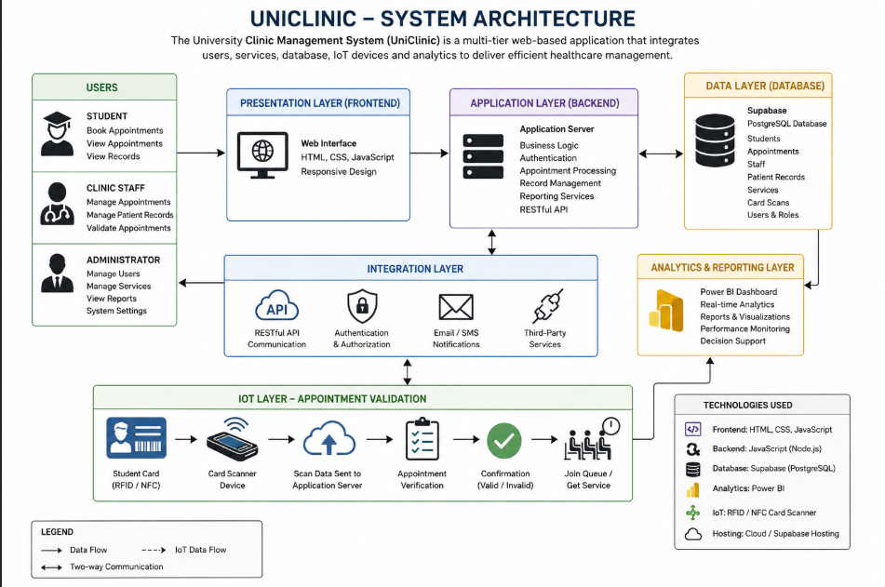

IoT Integration
The Internet of Things has also emerged as a significant technology within healthcare. IoT refers to interconnected devices capable of collecting and exchanging information in real time. In healthcare settings, IoT technologies are commonly used for patient monitoring, asset tracking, automated check-in systems, and operational management. Within the UniClinic project, student card scanning serves as an IoT solution that automates appointment validation and improves patient flow management.

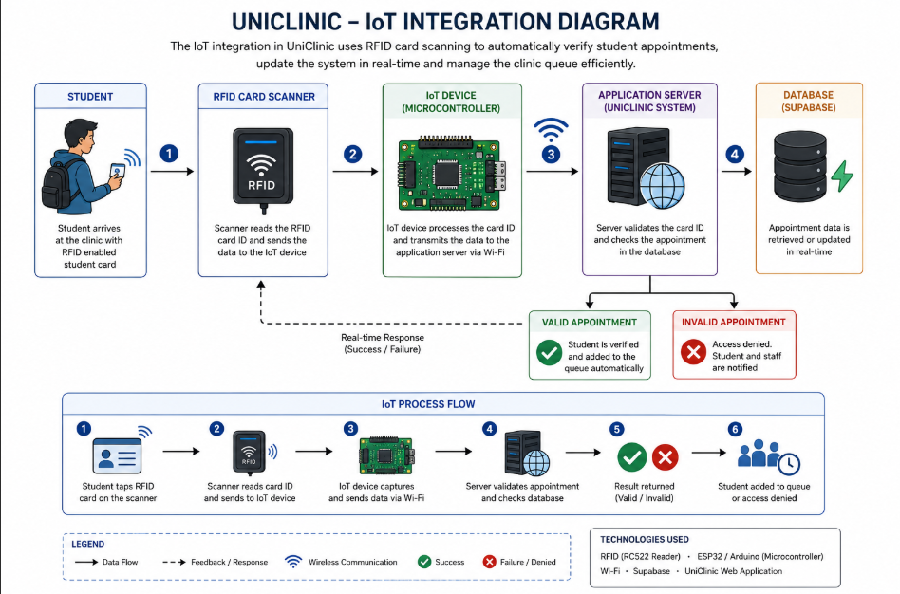

Business Intelligence Implementation
Business Intelligence technologies such as Power BI have transformed the way organizations analyse operational data. Healthcare facilities increasingly rely on analytical dashboards to identify trends, monitor performance, and support strategic planning. Through data visualization and reporting, management can gain valuable insights into patient behaviour, clinic utilization, and service demand patterns.

System Functionalities
The UniClinic system is divided into several functional iteratives that work together to provide a complete healthcare management solution. Each module performs specific tasks that contribute to the overall functionality and efficiency of the system. The modular design approach ensures that the system remains organized, scalable, and easy to maintain.
The user management iterative is responsible for handling user registration, authentication, and profile management. Students can create accounts, log in securely, and manage their personal information. Clinic staff and administrators are also authenticated through this module, ensuring that only authorized users can access system resources.
The appointment management iterative enables students to schedule appointments online by selecting available dates and times. The module stores appointment information in the database and allows users to view, modify, or cancel appointments when necessary. This functionality reduces administrative workload and minimizes scheduling conflicts.
The patient record management iterative allows clinic staff to create, update, and maintain electronic patient records. Healthcare practitioners can record diagnoses, treatments, prescriptions, and follow-up recommendations. The digital storage of patient records reduces the risk of lost or damaged files.
The appointment validation iterative incorporates Internet of Things (IoT) technology through RFID-enabled student cards. When students arrive at the clinic, they scan their cards using the RFID reader. The system verifies the appointment details and automatically updates the queue management system. This process reduces waiting times and improves operational efficiency.
The reporting and analytics iterative provides clinic administrators with valuable operational insights through Power BI dashboards. The module generates reports related to appointment statistics, patient trends, clinic utilization, and service demand. These reports assist management in making informed decisions regarding staffing, resource allocation, and service improvements.
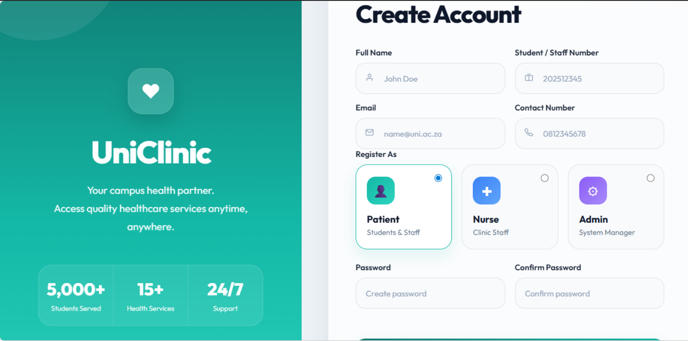
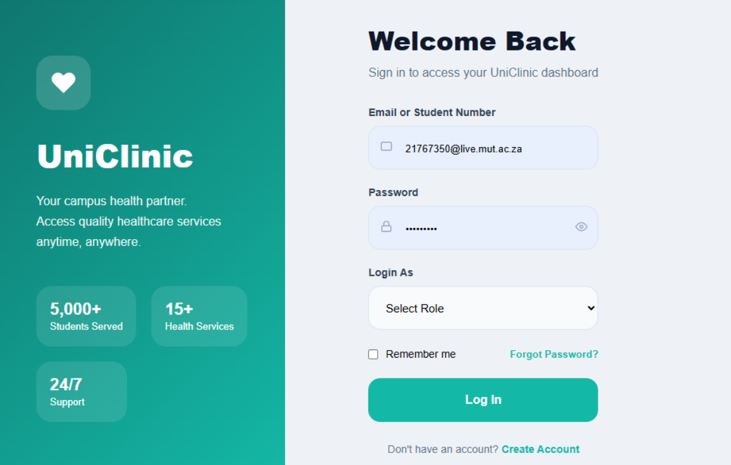
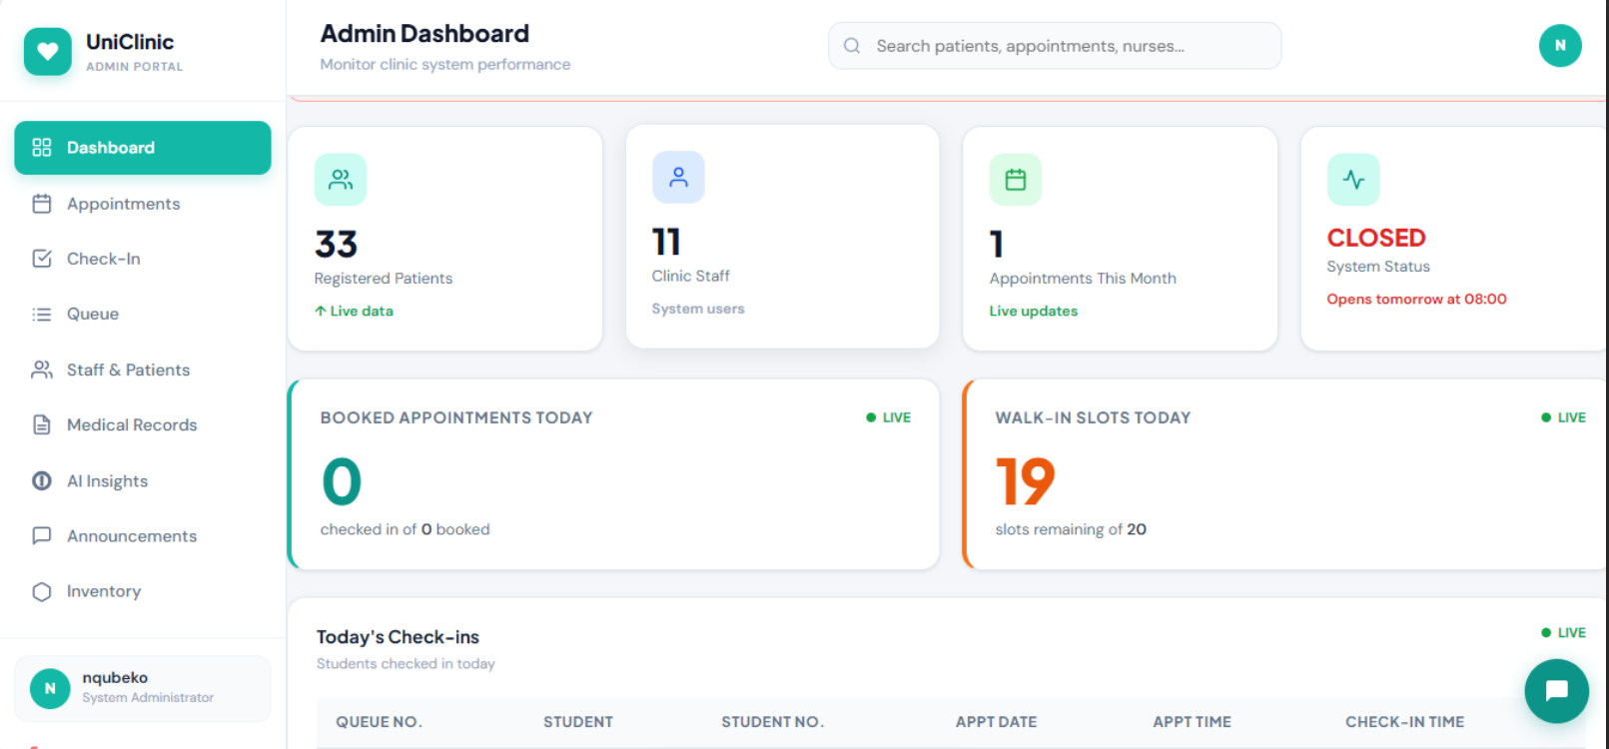
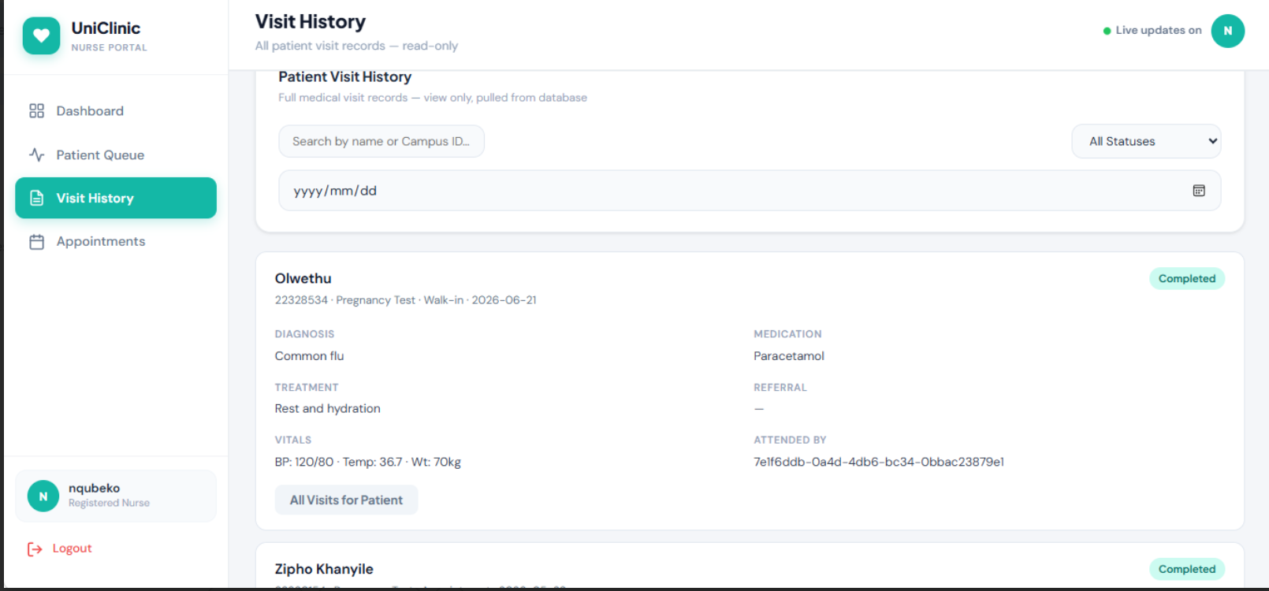

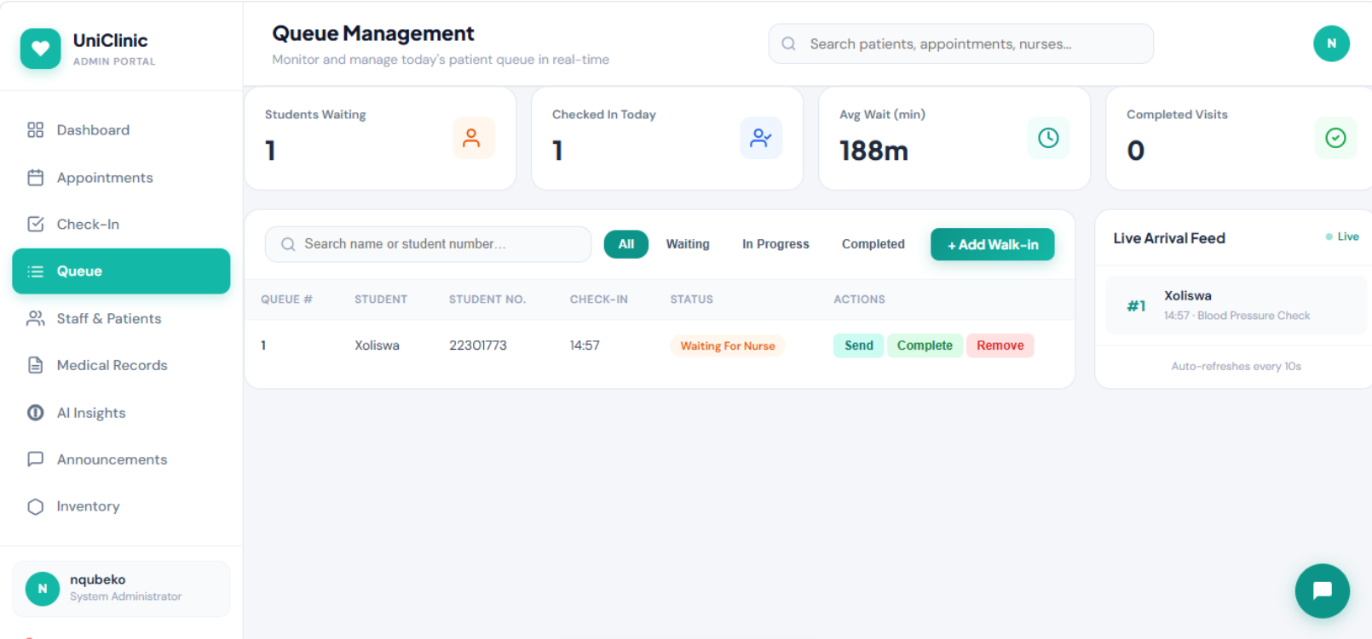

SECURITY ARCHITECTURE
Security is a critical component of any healthcare information system because patient information is highly sensitive and confidential. The UniClinic system incorporates a multi-layered security architecture designed to protect user data, prevent unauthorized access, and maintain system integrity. The security framework ensures that confidentiality, integrity, and availability are maintained throughout all system operations.
The first layer of security involves authentication mechanisms that verify the identity of users before granting access to the system. The second layer focuses on authorization and access control. Data security measures are implemented to protect information both during transmission and while stored in the database.
The system also incorporates audit logging and monitoring mechanisms that track user activities. These logs provide accountability by recording actions such as logins, appointment modifications, and patient record updates. Regular system backups are performed to prevent data loss and support disaster recovery procedures. Together, these security measures ensure that the system remains reliable, secure, and compliant with healthcare data protection requirements.

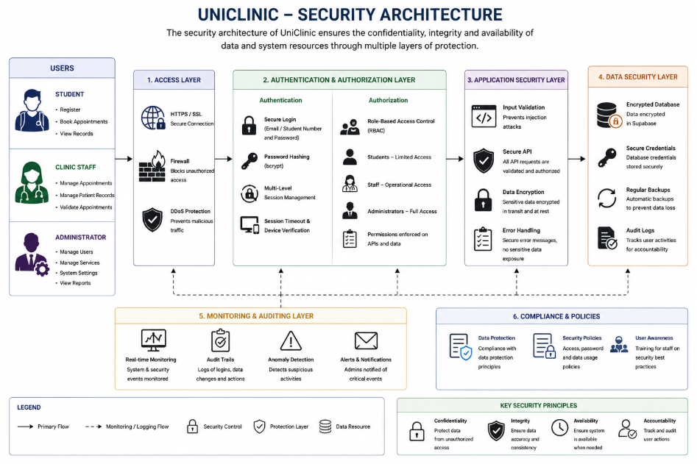

Testing and Evaluation
Testing was conducted throughout the development process to ensure that the UniClinic system met its functional and non-functional requirements. The primary objective of testing was to verify that all system components operated correctly, efficiently, and securely under various conditions. Multiple testing methods were used to evaluate system performance and identify potential issues before deployment.
Functional testing was performed to verify that individual system features operated according to specifications. Usability testing was conducted to evaluate the ease of use of the system. Performance testing was undertaken to assess the system's ability to process multiple requests and manage data efficiently. Security testing was also performed to evaluate the effectiveness of authentication and access control mechanisms.
The overall evaluation of the project indicates that the UniClinic system successfully achieved its objectives. The implementation of digital appointment scheduling, electronic patient records, IoT-based appointment validation, and Power BI analytics significantly improved operational efficiency and service delivery. The results demonstrate that the system provides a practical and effective solution for modernizing healthcare management within a university clinic environment.

